AAW Z05 AuAg
Those who listen will find the way.
善听者，终能找到道路。
AuAg Launch Edition Product Literature Draft
Universal 5-driver hybrid in-ear monitor with TwinCore Crossover Switch System
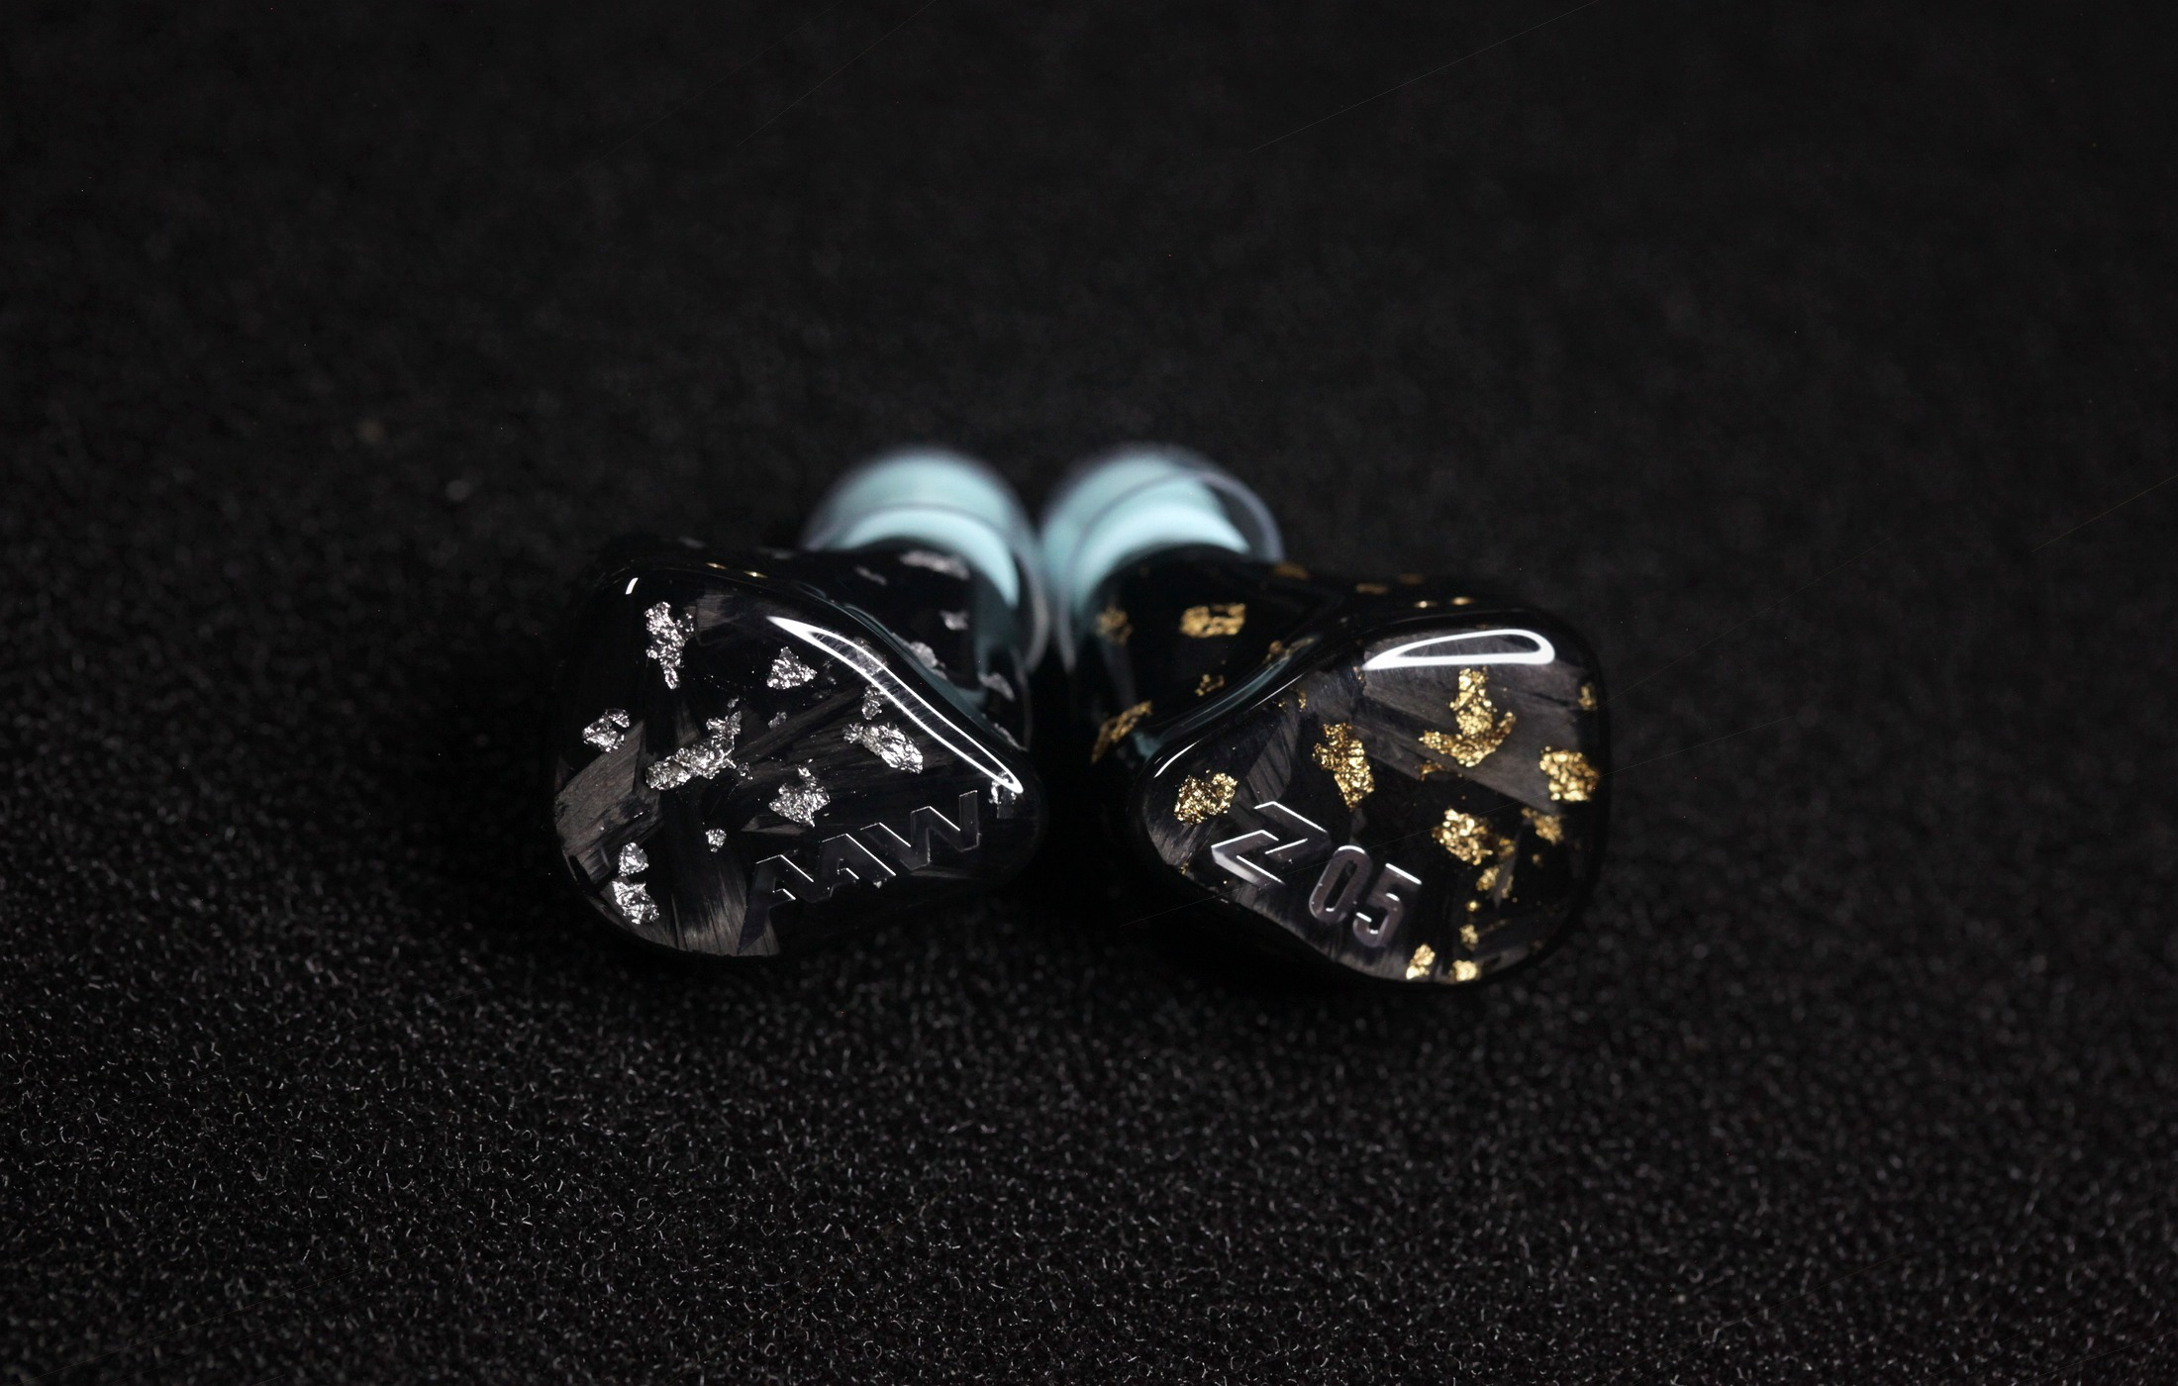
Edited launch hero from IMG_5345.JPG: forged carbon faceplates with gold right and silver left foil lacing.

Positioning
Z05 AuAg is the AuAg Launch Edition of AAW's Z05 universal in-ear monitor platform. It is derived from the Z06 design philosophy, then reshaped around a new PET diaphragm 10mm dynamic woofer, switchable full-spectrum crossover tuning, and a forged-carbon shell finished with gold foil on the right side and silver foil on the left.
Field | Detail
Product name | AAW Z05 AuAg Universal In-Ear Monitor
Edition naming | AuAg Launch Edition
Architecture | 5-driver hybrid: 1 x 10mm PET dynamic woofer, 2 x mid BA drivers, 2 x super-high BA drivers
Crossover | 3-way passive crossover with TwinCore Crossover Switch System
Acoustic system | Bass-Flow Vent Pressure System
Cable | 2-pin detachable cable with swappable 3.5mm stereo, 4.4mm balanced, and Type-C terminations
Fit system | LiquidMorph eartips
Specifications | Sen.: 110dB @ 1kHz; Imp.: 12Ohm @ 1kHz; THD: <0.5% @ 1kHz

Hero Copy

Long Form
AAW Z05 AuAg is a universal-fit hybrid in-ear monitor designed for listeners who want both acoustic authority and personal control. Built around a new PET diaphragm 10mm dynamic woofer, Z05 delivers a physical low-frequency foundation while preserving the spacious, high-resolution character of the Z series. Its TwinCore Crossover Switch System changes between two complete crossover states, giving listeners a direct way to reshape the monitor's presentation across the full spectrum.
The AuAg Launch Edition turns that acoustic platform into a more distinctive visual object. Forged carbon faceplates sit inside a deep black universal shell, with gold foil laced through the right earpiece and silver foil laced through the left. The finish continues through the body shell, making the gold/silver identity part of the whole monitor rather than a faceplate-only accent.

Short Form
Z05 AuAg is where power, control, and craft meet: a PET diaphragm dynamic woofer, TwinCore full-spectrum tuning, modular source connection, and a forged-carbon AuAg shell built for the Launch Edition.

Product Card
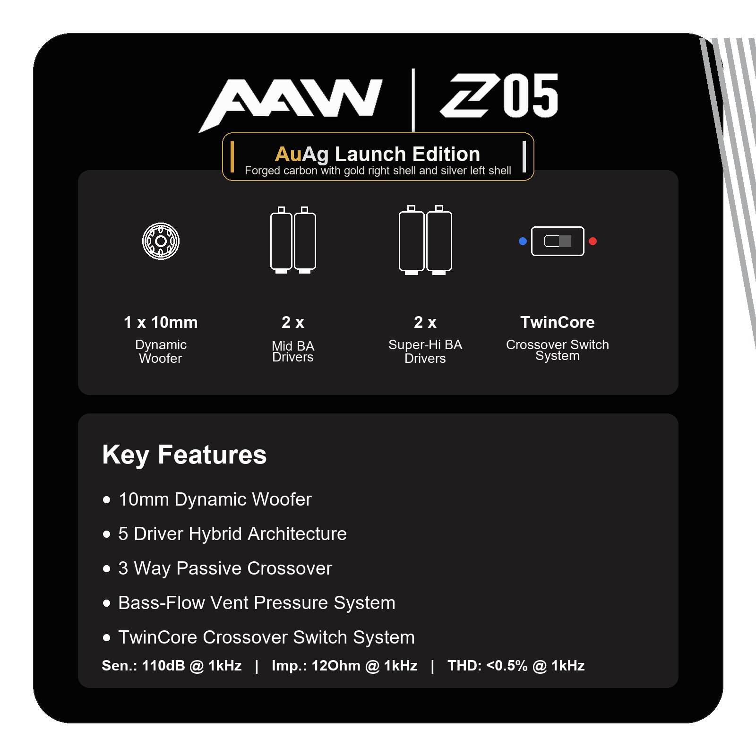
Updated product card: AuAg Launch Edition, corrected key features, and final published specifications.

TwinCore Crossover Switch System
The Z05 switch is not a conventional one-component on/off switch. It changes between two complete crossover circuit states. The blue position places 20Ohm loading on both low-frequency and high-frequency paths. The red position changes the low-frequency path to 40Ohm and shorts the high-frequency path to 0Ohm. Because both paths are affected, the response changes across the whole spectrum rather than only boosting or cutting one band.
Field | Detail
Market name | TwinCore Crossover Switch System
English slogan | Two complete crossovers. Two Z05 AuAg characters.
Chinese slogan | ??????????????
Blue position | Low-frequency path: 20Ohm; high-frequency path: 20Ohm
Red position | Low-frequency path: 40Ohm; high-frequency path: 0Ohm
Customer benefit | A broader voicing shift that changes bass weight, vocal balance, and upper-frequency presence together.

AuAg Exterior Story
The Z05 AuAg exterior is designed to feel more jewelry-like than a standard universal monitor while staying technical and dark. Each side uses a forged carbon faceplate with matching foil lacing through the corresponding shell body: gold for the right ear and silver for the left. Under the glossy black shell, the foil creates layered depth and a mineral-like shimmer.
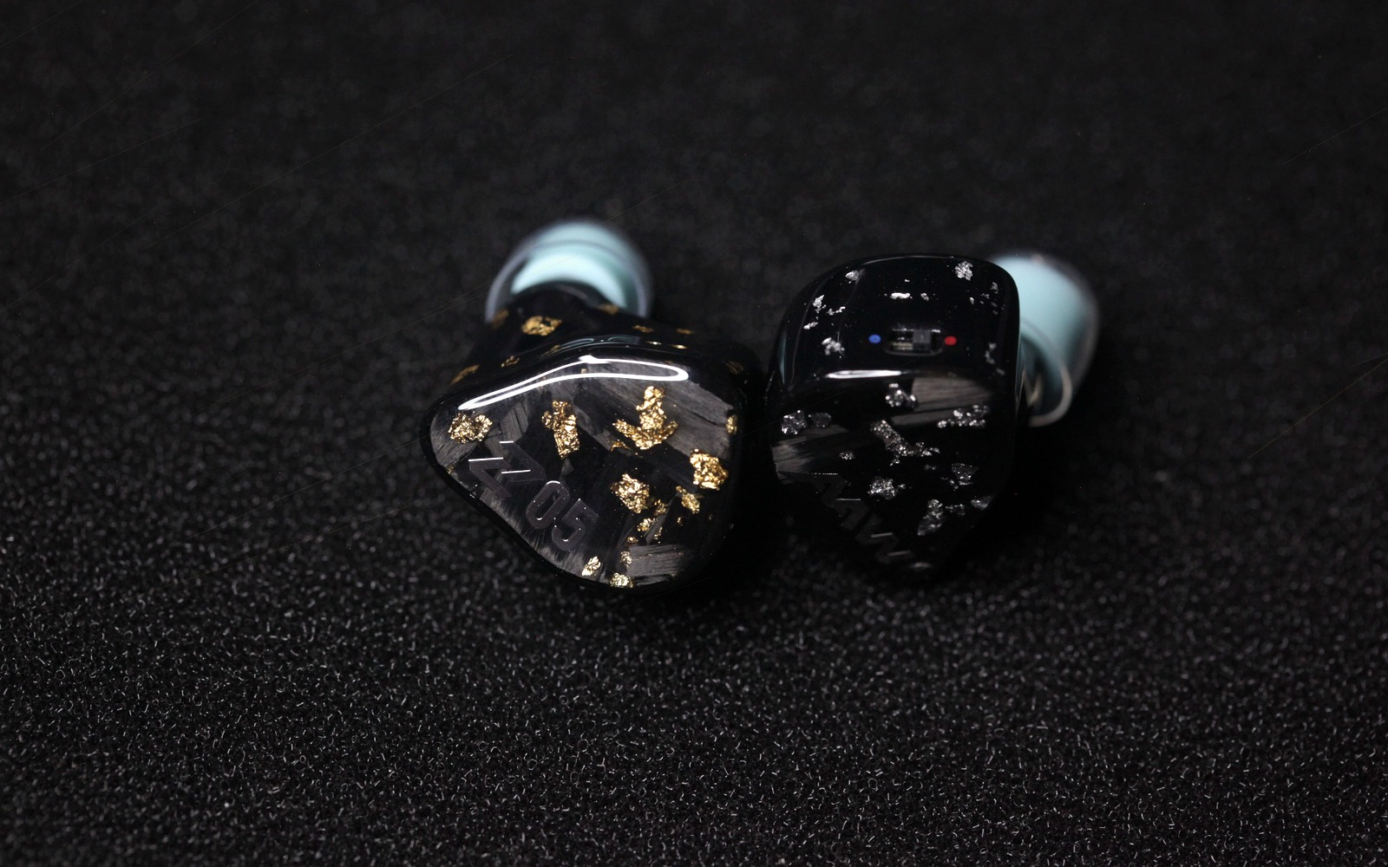  Gold right and silver left faceplate view. | 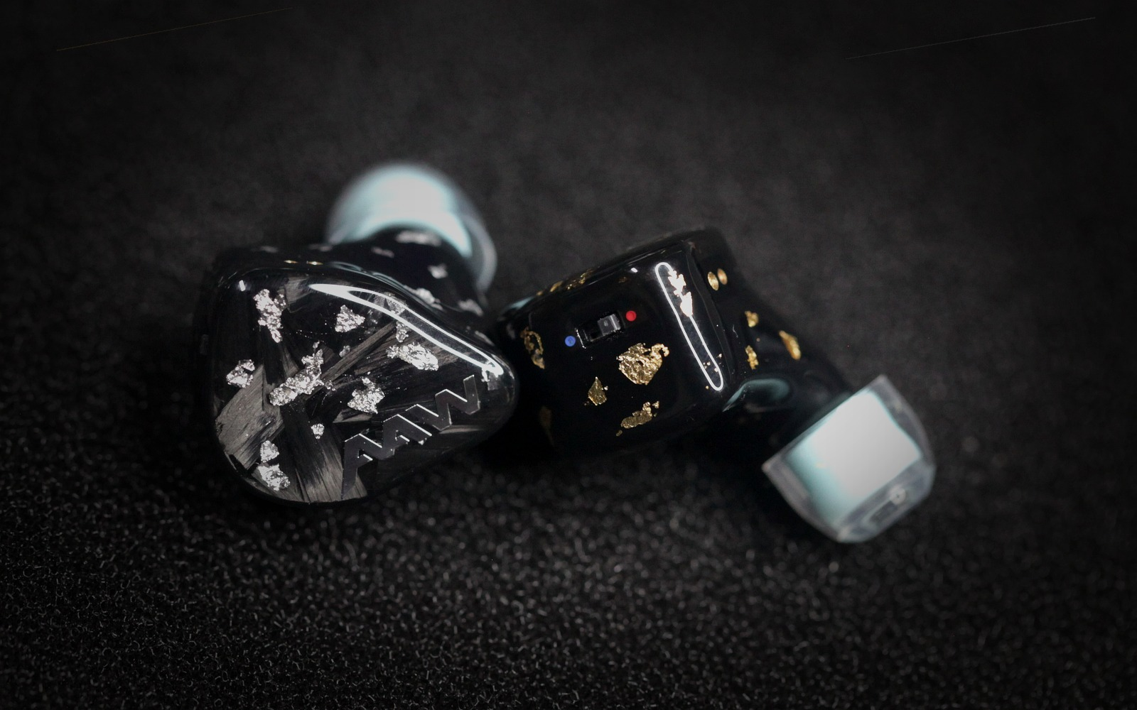  Switch close-up showing blue/red position marking.

Accessories And Fit
Z05 AuAg has the same general accessory direction as Z06, with one important update: the cable is a new entry-level detachable cable with a practical multi-connector system. The cable itself does not need a branded name; the selling point is simple source flexibility across 3.5mm stereo, 4.4mm balanced, and Type-C.
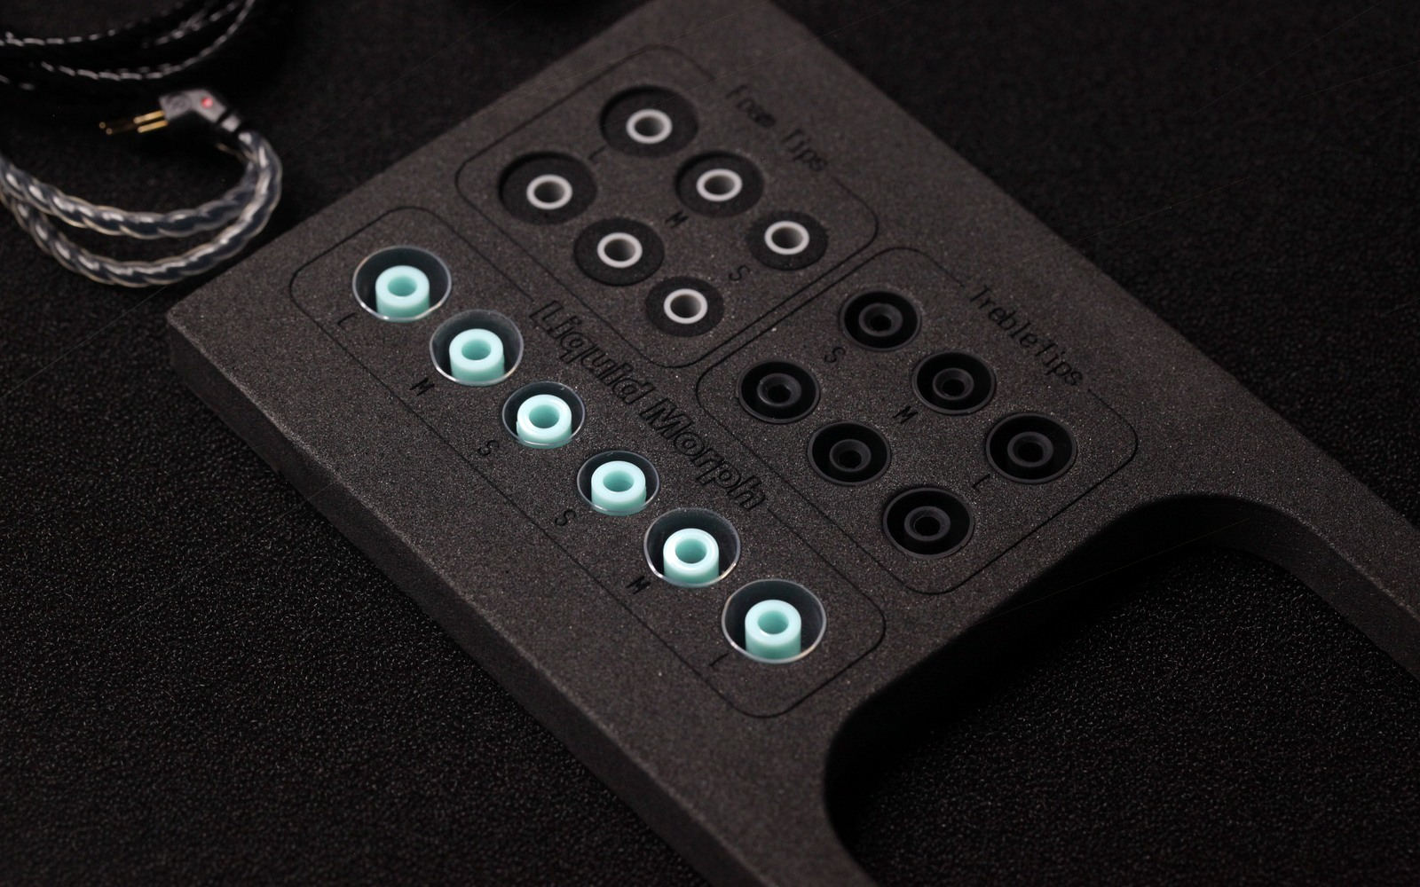
Accessory-section image: LiquidMorph tray context with Z05 AuAg package components.
Field | Detail
Included monitors | Z05 AuAg universal in-ear monitor pair
Included cable | 2-pin detachable cable with swappable source-side connector system
Termination options | 3.5mm stereo, 4.4mm balanced, Type-C
Fit accessories | LiquidMorph eartips
Other accessories | Carrying case and standard support accessories aligned with the Z-series package direction

LiquidMorph Eartips
The LiquidMorph section should use the standalone eartip image rather than the tray image, because the eartip-only visual clearly shows the transparent flange shape and teal inner bore. This makes the fit-system explanation clearer than a tray-context photo.
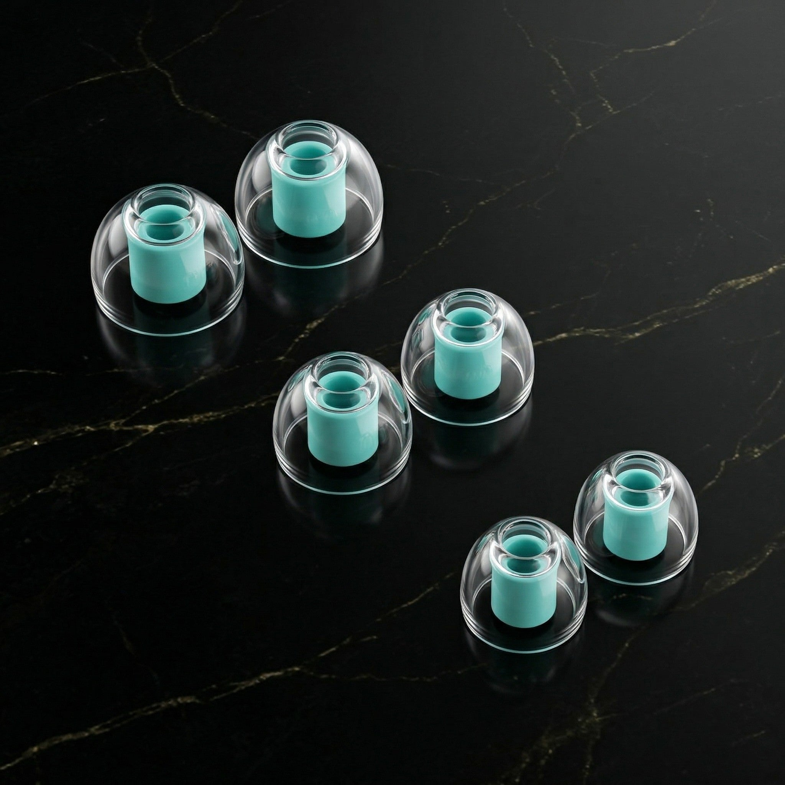
LiquidMorph section image: eartip-only visual for clear shape recognition.

Selected Launch Image Set
Eight edited images were selected from the supplied dump for the product page and literature. The set balances hero appeal, finish detail, switch access, cable practicality, accessory context, and eartip explanation.
  IMG_5345.JPG - Hero faceplate view |   IMG_5355.JPG - Gold/silver forged-carbon faceplates

  IMG_5324.JPG - Switch close-up with clear blue/red position | 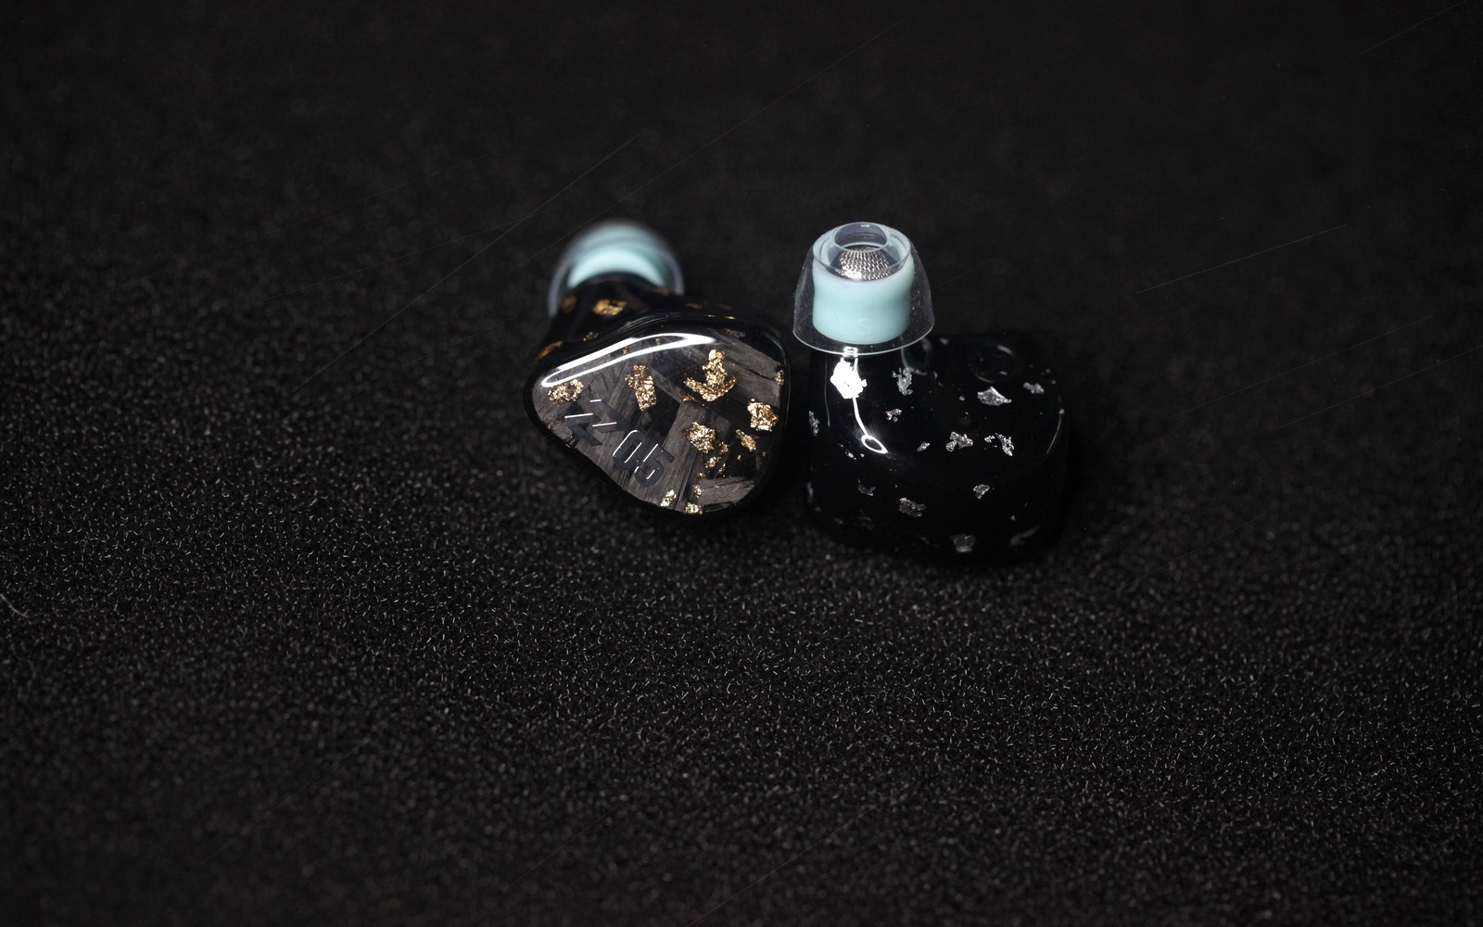  IMG_5328.JPG - AuAg shell angle

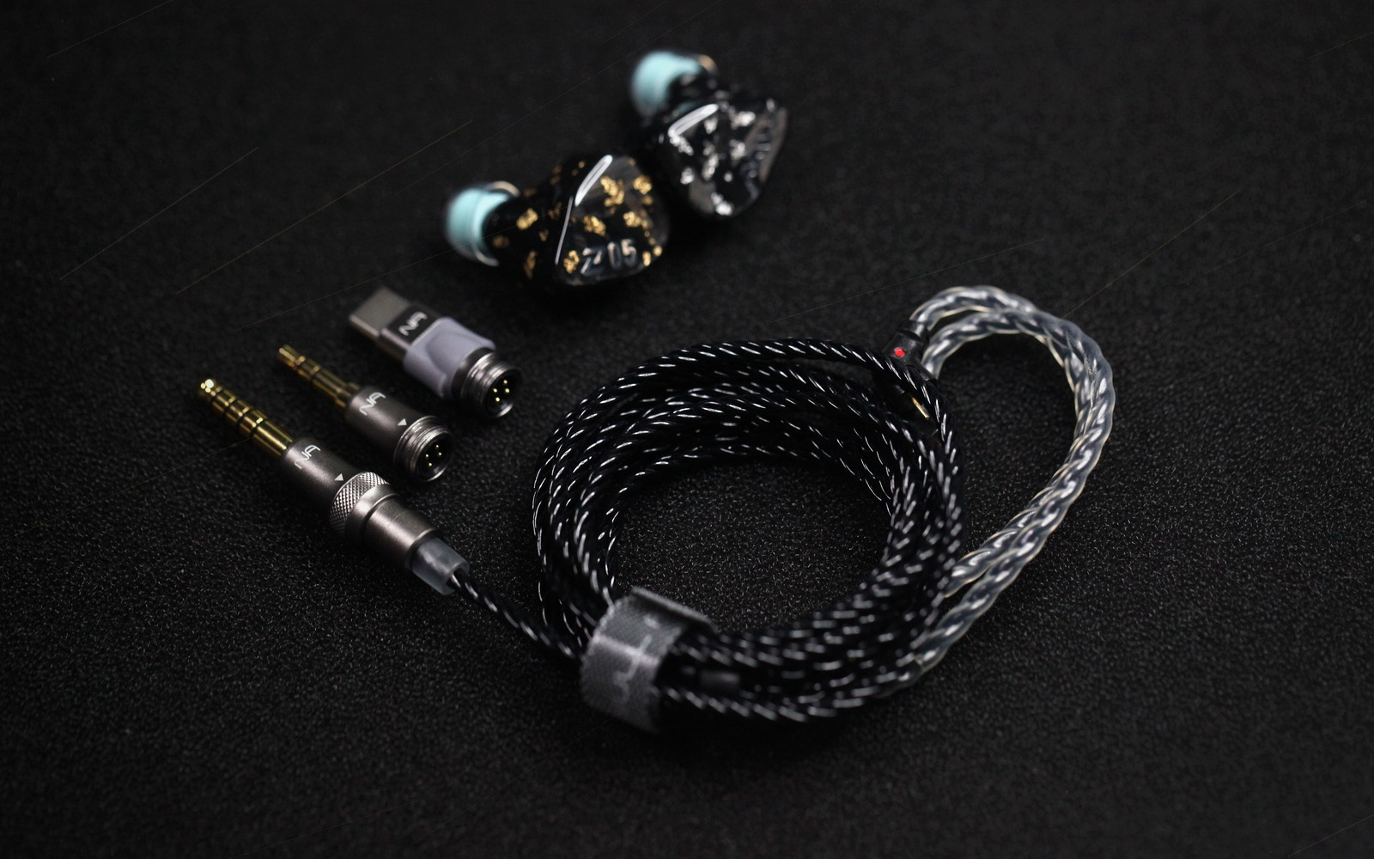  IMG_5311.JPG - Swappable termination cable system | 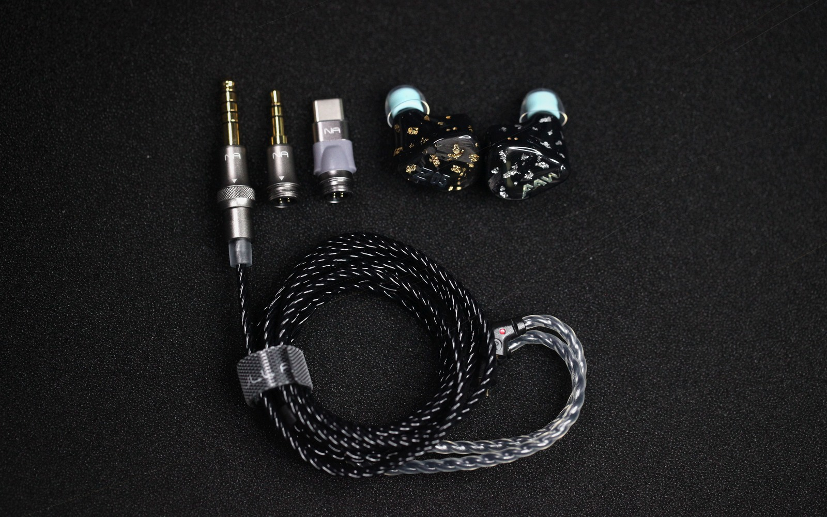  IMG_5310.JPG - Full package flatlay

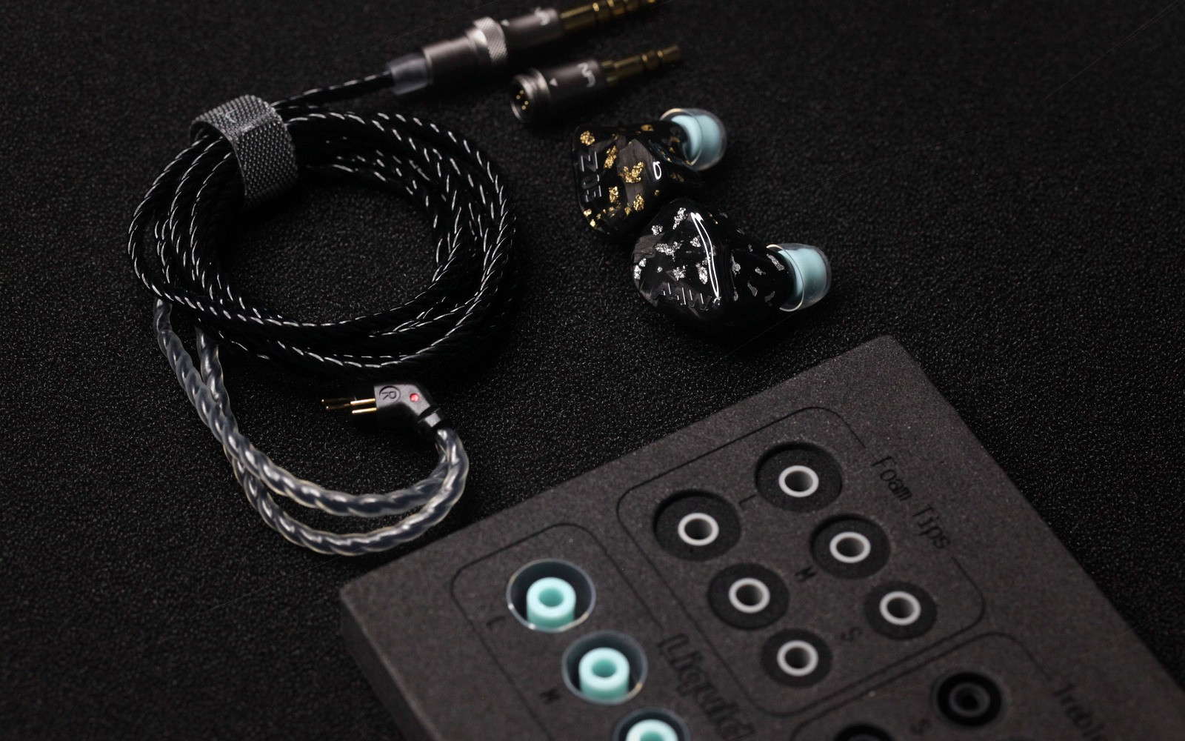  IMG_5334.JPG - Accessories and fit system |   IMG_5336.JPG - Accessory tray context

Product Page Notes
- Use AuAg Launch Edition in customer-facing copy instead of launch variant.
- Use the selected hero image as the first editorial signal on the product page.
- Use the LiquidMorph tray image in the accessories section only.
- Keep the standalone LiquidMorph eartip image in the LiquidMorph section for clearer shape communication.
- Keep product configuration and checkout in the Shopify product module, while editorial sections explain the launch finish and acoustic design.

